**Holy Cross College (Autonomous), Nagercoil**

**An ISO 9001: 2015 Certified Institution &**

**Accredited with ‘A+’ Grade (CGPA 3.35 - IV Cycle) by NAAC**

**Affiliated to Manonmaniam Sundaranar University, Tirunelveli**

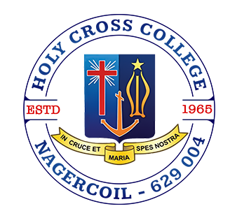

**Department of Zoology**

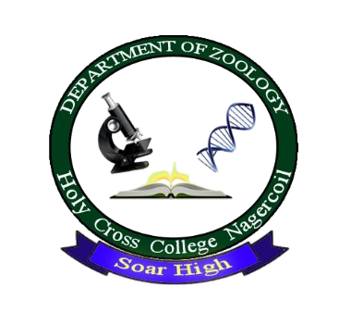

**Report**

**Department Bridge Course**

**04-07-2024**

**Theme**

“Introduce students to the academic and extracurricular activities available in their respective program”

**Objective**

To align students with the Vision and Mission of the Department of Zoology and explain the principles of Outcome-Based Education (OBE) and to educate students on the Program Outcomes (POs) and Program Specific Outcomes (PSOs) of the Zoology Program. To provide insights into various career opportunities available in the field of Zoology.

**Organizer:** Department of Zoology

The I B.Sc. Zoology students participated in a Bridge course organized by the Department of Zoology. Dr. S. Mary Mettilda Bai, Associate Professor of Zoology, briefed them on the Vision and Mission of the college. Dr. F. Brisca Renuga, Associate Professor, explained Outcome-Based Education, Program Outcomes (POs), and Program Specific Outcomes (PSOs). She also expanded on the concept of outcome-based education and discussed the POs and PSOs of the Zoology Program. Dr. C. Josephine Priyatharshini, Assistant Professor of Zoology, focused on terminology pertinent to the field of Zoology. Dr. A. Punitha, Assistant Professor of Zoology provided insights into various career opportunities, higher education options, and entrepreneurial prospects available in the field of Zoology. Dr. A. Shyla Suganthi, the Head and Associate Professor of Zoology, elaborated on the career prospects of studying Zoology. Finally, Dr. Jeni Chandar Padua, Assistant Professor of Zoology, discussed the entrepreneurial opportunities associated with studying Zoology. Around 27 students participated in the programme.

**Outcome:**

The Bridge course provided students with valuable knowledge, practical insights, and inspiration for their academic and professional futures in Zoology. The program successfully prepared students to navigate their educational journey and explore the vast opportunities within the field of Zoology.

**Impact:**

The Bridge course had a significant and positive impact on the students by providing them with critical knowledge, practical insights, and inspirational guidance. The program effectively prepared students to navigate their academic journey and explore the vast opportunities within the field of Zoology, setting a strong foundation for their future success.

**Brochure**

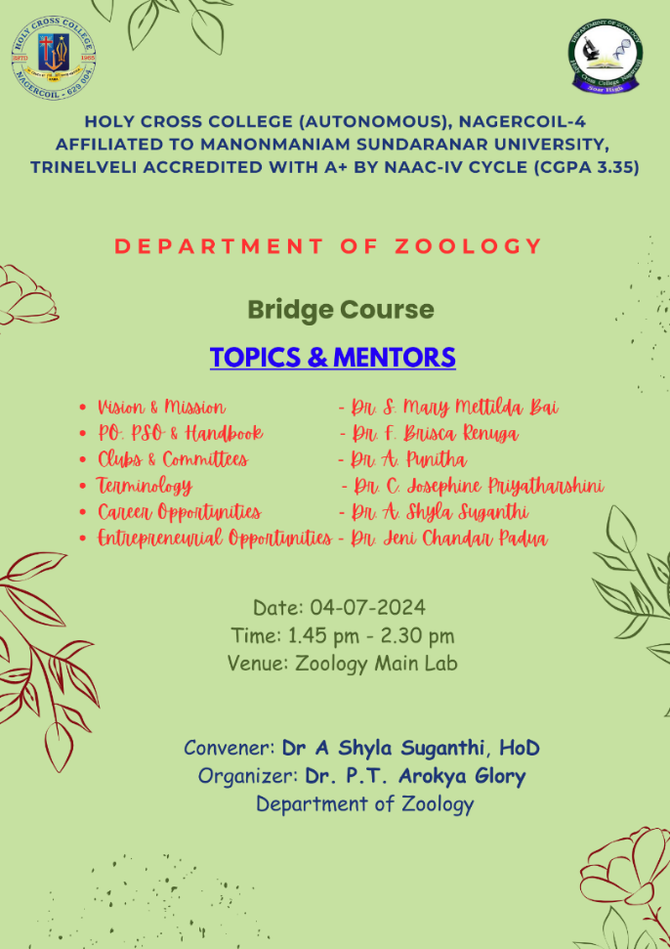

**Photos:**

